SOP FOR

1.0 Purpose: - Safe Maintenance of MECAWBAR pneumatic lime handling system
- Scope: - Sinter plant.

3.0 Responsibility: - Engineer In charge and workmen on the job
- Procedure: - MAINTENANCE OF MECAWBAR (PNEUMATIC) LIME HANDLING SYSTEM

PPEs to be used: - Helmet, Safety shoes, hand gloves, Dust mask, ear plug, safety goggle (full protection goggle), full body apron, face shield and safety belt.
- Activity No 1: - Replacement of Inflatable seal of dome valve.
- Activity No 2: - Replacement of dome valve.
- Activity No 3: - Replacement of shaft bearing.
- Activity No 4: - Replacement of dump valve and seal.
- Aspect – impact: -
Scrap generation  Dust Generation | Resource Depletion  Air Pollution
- Hazards identified -
Mechanical hazard
- Inhaling of burnt lime
- Fall of burnt lime from top
- Injury due to compressed air & pipes.
- Accident due to improper shutdown
- Failure of sling, chain pulley block, improper hook welding
- Fall of a person.
- Entering of burnt lime in eyes.
- Skin infection due to burnt lime

Electrical hazard
- Electrical shock in welding and from uncertified/ improper electrical tools

Do’s: -
- Always cover nose with mask to avoid inhaling of burnt lime while working in lime systems
- Always cover eyes with full protection goggle (tight fit, rubber band) as well as face shield also to be used to avoid direct contact of burnt lime with face skin
- Always use full body apron while working in quick lime system to avoid skin infection
Don’t: -
- Never ever start to work on lime conveying system without proper shutdown and without releasing trapped air pressure in line by using relief valve.
- Below is the pics attached of available relief valves in Sinter plant lime conveying system.
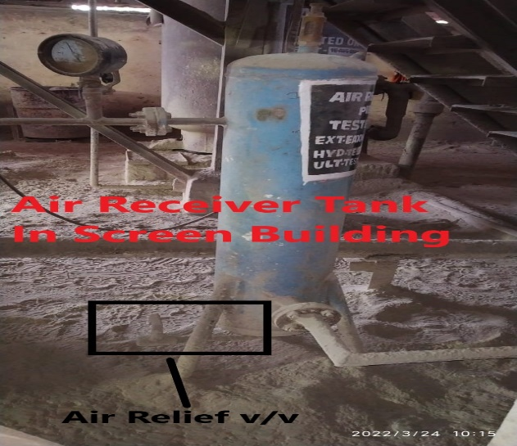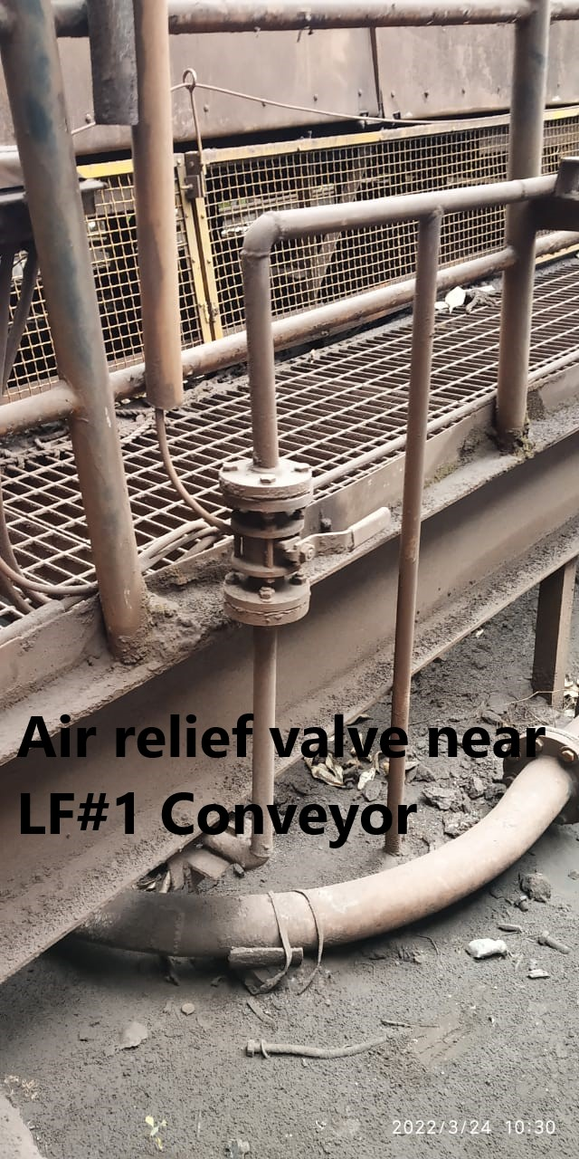

Procedure: -
Activity No 1: - Replacement of Inflatable seal of dome valve
- Take electrical shutdown of lime handling system.
- Isolate and lockout air main valve and drain all residual pressure from the system & receiver tank.
- If more than one worker is relying on the protection of an isolation, then all workers should apply their own locks in master lock out box
- Press local push emergency button of the lime system.
- Disconnect the dome valve from isolating valve or feed chute.
- Lower the valve or vessel to gain access to the valve top plate.
- Remove the socket head bolts that hold the top plate to the Dome valve body.
- Note the orientation of the top plate seal inflation connector with respect to the valve body then remove the complete top plate assembly from the valve body top plate includes the inflatable seal; inserting, spigot piece.
- Remove the inflatable seal from insert ring.
- Clean the surface & holes for any choke ups.
- Replace the inflatable seal if worn or cut, fix it at proper orientation.
- Assemble the dome valve top plate & fix back in position.
- Fix back isolating valve or feed chute.
- Ensure all bolts & gaskets are fixed properly
- Close all the drain valves and open the inlet line.
- Clear the electrical shut down and take trial.
- Check all the pressures as required and take trial jointly.
- Hand over to operation.

Activity No 2: - Replacement of dome valve
- Isolate and lockout air main receiver, and drain all residual pressure from the system & Receiver tank.
- If more than one worker is relying on the protection of an isolation, then all workers should apply their own locks in master lock out box.
- Disconnect the dome valve from isolating valve or feed chute.
- Lower the valve or vessel to gain access to the valve top plate.
- Remove the valve bottom flange bolts.
- Remove the valve from the vessel or component & place on a clean, dry flat surface.
- Disconnect the dome actuator by removing the retaining bolts, ensure that the dome component is well supported to prevent uncontrolled movement when the actuator is disconnected.
- Remove the socket head shoulder bolts the dome to the two shafts (drive & pivot shafts).
- Remove the dome component, and place on a clean, dry, flat surface
- Withdraw the shafts from the valve body and inspect for wear or damage.
- Always replace shaft seals when the shafts are removed.
- Reassemble the dome valve top plate & fix back in position.
- Fix back isolating valve or feed chute.
- Ensure all bolts & gaskets are fixed properly
- Close all the drain valves and open the inlet line.
- Clear the electrical shut down and take trial.
- Check all the pressures as required and take trial jointly.
- Hand over to operation.

Activity No 3: - Replacement of shaft bearing.
- Isolate and lockout air main receiver, and drain all residual pressure from the system & receiver tank.
- If more than one worker is relying on the protection of an isolation, then all workers should apply their own locks in master lock out box
- Disconnect the dome valve from isolating valve or feed chute.
- Lower the valve or vessel to gain access to the valve top plate.
- Remove the valve bottom flange bolts.
- Remove the valve from the vessel or component & place on a clean, dry flat surface.
- Disconnect the dome actuator by removing the retaining bolts; ensure that the dome component is well supported to prevent uncontrolled movement when the actuator is disconnected.
- Remove the socket head shoulder bolts the dome to the two shafts (drive & pivot shafts).
- Remove the dome component, and place on a clean, dry, flat surface
- Remove the seal retaining rings& shaft seals to the inside of the valve body.
- Using bearing press and small stock slightly smaller than bearing OD, press the bearing out of the valve body to the inside of the valve.
- Press the new bearing into valve body from the outside of the valve, ensuring grease holes are correctly aligned.
- Reinstall shafts, ensuring that the shafts are clean& have no burrs until the shaft boss bottoms out against the bearing housing.
- Re install new shaft pressure seals & the seal retaining rings.
- Reassemble in reverse order, ensuring that the drive shaft is fitted into the actuator mount end of the valve and that the limit striker arm is in the “UP” position
- Fix back isolating valve or feed chute.
- Ensure all bolts & gaskets are fixed properly
- Close all the drain valves and open the inlet line.
- Clear the electrical shut down and take trial.
- Check all the pressures as required and take trial jointly.
- Hand over to operation

Activity No 4: - Replacement of dump valve seal.
- . Take electrical shutdown of lime handling system.
- Isolate and lockout air main valve, and drain all residual pressure from the system & receiver tank.
- If more than one worker is relying on the protection of an isolation, then all workers should apply their own locks in master lock out box
- Press local push emergency button of the lime system.
- Remove the top valve of dump valve.
- Lift the dump valve inner assembly with chain block/hoist.
- Remove the socket head bolts that hold the top plate to the Dome valve body.
- Note the orientation of the top plate seal inflation connector in relationship to the valve body then remove the complete top plate assembly from the valve body top plate includes the inflatable seal; inserting, spigot piece.
- Remove the inflatable seal from insert ring.
- Clean the surface & holes for any choke ups.
- Replace the inflatable seal if worn or cut, fix it at proper orientation.
- Lower the dump valve inner assembly with chain block/hoist.
- Fix the top flange.
- Close all the drain valves and open the inlet line.
- Clear the electrical shut down and take trial.
- Check all the pressures as required and take trial jointly.
- If found satisfactory hand over to operation.

LIMIT SWITCH SETTING: -
Set the Dome in fully closed position.
Loosen limit switch retaining bolts & push limit switch up until the limit switch is depressed.
Tighten retaining bolts after limit switch adjusted correctly.

NOTE: -
Failure to ensure that limit switch is adjusted correctly can result in premature failure, seal wear & damage to Dome valve components.
To ensure proper operation of the Dome valve, the seal pressure must be a minimum of 25PSIG above the maximum operating internal process pressure of the system
Failure to maintain this minimum pressure differential could result in leakage between the seal & dome causing severe damage to the dome valve components

Reference: - SP-44, OEM manual

Date | Manual Section Ref. & Para | Brief details of Revision | New Rev.

Prepared By:  Associate Manager- Sinter Plant Mechanical | Reviewed & Issued By:  Management Representative | Approved By:  Manager- Mechanical PID2
Signature: | Signature: | Signature:
Review Date: 20.08.2022 | Review Date: 20.08.2022 | Review Date: 20.08.2022

